**GEOS5:**

The **Goddard Earth Observing System Model, Version 5 (GEOS-5)** is a system of models integrated using the Earth System Modeling Framework (ESMF). The GEOS-5 DAS integrates the GEOS-5 AGCM with the Gridpoint Statistical Interpolation (GSI) atmospheric analysis developed jointly with NOAA/NCEP/EMC. The GEOS-5 systems are being developed in the GMAO to support NASA's earth science research in data analysis, observing system modeling and design, climate and weather prediction, and basic research. (<https://geos5.org/wiki/>)

The GEOS-5 has seven ensemble members for 9-month experimental forecasts (missing three months data of February, March and April). The GEOS-5 seasonal forecast system provides monthly contributions to the NMME project to advance the capabilities of the climate prediction models. We selected the precipitation and air temperature variables out of 50 variables from the downloaded data as a start. (Kirtman, 2014, Borovikov, 2017)

The units for precipitation is given in is [Kg/m2/s] as total monthly precipitation, while temperature is given in [oK] average monthly temperature.

Spatial Coverage: 1.0 degree latitude x 1.25 degree longitude global grid (288lon x 181lat)

**Observations datasets:**

University of Delaware Air Temperature & Precipitation v.4.01

<https://www.esrl.noaa.gov/psd/data/gridded/data.UDel_AirT_Precip.html>

Spatial Coverage: 0.5 degree latitude x 0.5 degree longitude global grid (720lon x 360lat).

Temporal Coverage: 1900 to 2014 (115 years)

ftp link: <ftp://ftp.cdc.noaa.gov/Datasets/udel.airt.precip/>

A series of gridded temperature and precipitation data sets. Station records that served as bases for the Terrestrial Air Temperature: 1900-2014 Gridded Monthly Time Series (Version 4.01) and Terrestrial Precipitation: 1900-2014 Gridded Monthly Time Series (Version 4.01) archives are used here to help create new gridded climatologies of monthly and annual average air temperature (T) and total precipitation (P). These two sets of station time series were drawn primarily from recent versions of the Global Historical Climatology Network (GHCN v2 for precipitation and GHCN v3 for temperature) and the Global Surface Summary of Day (GSOD) archive. Values of precipitation or temperature is a local grid-point estimate, not grid-cell average or raster data. The precipitation data are not corrected for rain-gauge undercatch, and the accuracy of the gridded fields depends on the station density. <https://climatedataguide.ucar.edu/climate-data/global-land-precipitation-and-temperature-willmott-matsuura-university-delaware>

Temperature:

<http://climate.geog.udel.edu/~climate/html_pages/Global2014/README.GlobalTsP2014.html>

Precipitation:

<http://climate.geog.udel.edu/~climate/html_pages/Global2014/README.GlobalTsT2014.html>

**Terciles:**

Terciles are the two values that divide the historical time series record into three partitions assuming normal distribution of the data, where one third of the observations fall below the lower tercile value (Below Normal), one third of the values above the upper tercile value (Above Normal) and one third of the values between the lower and upper tercile values (Normal).

**Preparing input files:**

Observation data regridded to match GEOS-5 grid using CDO:

*cdo remapbil,<GEOS-5 file> < udel.air.mon.mean.v401.nc > < udel.air.mon.mean.grided.nc >*

Data split into one file for each month from 1900 to 2014:

*splitmon <udel.air.mon.mean.grided.nc> <udel.air.mon_>*

Monthly Climatology terciles created using CDO percentiles command:

*cdo runpctl,<P>,<timesteps> < udel.air.mon_01.nc > < udel.air.p66.67.mon_01>*

P=33.33 or 66.67, timesteps=115

Merged the terciles climatology into one file:

*cdo mergetime < udel.air.p66.67.mon_*> <udel.air.p66.67.mon.1900_2014.nc>*

To select variables from GEOS-5 (or any) model:

*cdo selname,<VAR1>,<VAR2>,<VARn> <infile.nc> <outfile.nc>*

*\*remove between <> with your input.*

Extracted timeseries for terciles are shown below as threshold for colored regions, which repeats the same every year. The extracted timeseries for the same region from the forecast model is plotted over the terciles to show the status of the forecasted variable whether below or above normal observed variable.

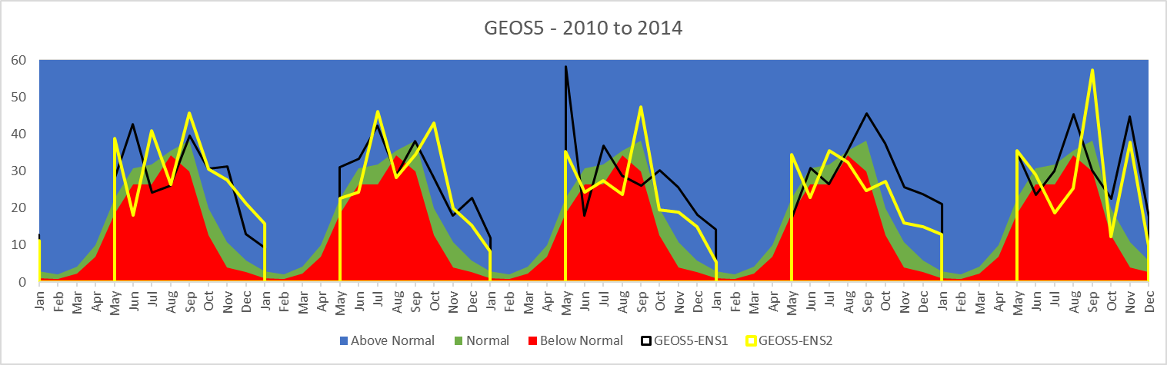

In this example, timeseries is extracted for one grid point at 15N and 107.5E (LAT#105, LON#230), and only 2 ensembles members are plotted.

For these data files to be consumable by a Tethys application, further computations and file manipulations needed to occur. From the GEOS-5 ensemble forecast files, the mean, min, and max forecasts (Precip values converted from Kg/m2/s to cm, temperature values converted from K to ºC) were computed for each time step and variable in the dataset using a python script. This script also converted the netcdf files into geoTIFF files that are readable by Tethys. The final step to get the files ready to display in Tethys was to upload the files to geoserver with a consistent naming convention.

GEOS-5 data naming convention – ‘YYYYMM_VARIABLENAME_stat.tif’

* Example: The file name for the mean precipation forecast for December 1983 is ‘198312_PRECTOT_mean.tif’

There is a separate python script that was used to upload the files to an instance of geoserver.

GeoServer workspace:datastore naming convention – ‘MODEL_VARIABLENAME_stat:YYYYMM’

* Example: The workspace:datastore name for the minimum 2-meter air temperature forecast for June 1999 is ‘GEOS5_T2M_min:199906

The python scripts mentioned here are available in the github repository for the NMME Forecast Viewer Tethys APP at <https://github.com/spence97/tethysapp-nmme_viewer.git> and are called compute_stats_prec.py, compute_stats_temp.py, and upload_geotiff_GEOS5.py.

**NMME Forecast Viewer Tethys Application:**

Using the input files discussed above, a Tethys web application was created as a way to visualize this data, allowing for user-defined queries of forecast year, forecast month, model, variable, and ensemble statistic as shown below.

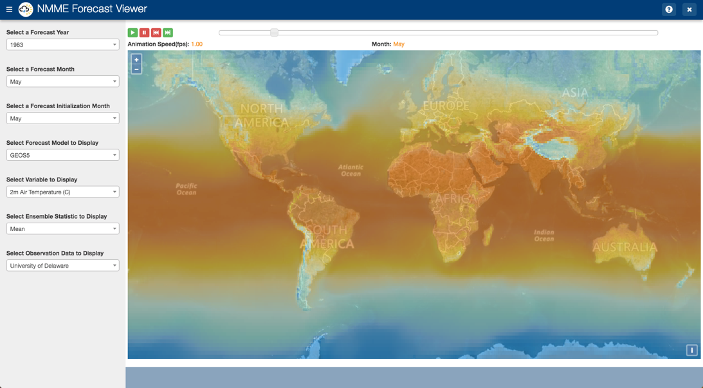

In the example shown above, the map is displaying the average forecasted (computed from the 7-ensemble members) 2-meter Air Temperature (ºC) in May of 1983.

Current list of available options:

* Year – 1983-2015
* Month – May-January (of the following year)
* Forecast Initialization Month – May
* Model – GEOS-5
* Variables – Monthly Precipitation (cm) and 2-meter Air Temperature (ºC)
* Statistics – Mean, Min, Max
* Observational Data – University of Delaware (though the app does not currently do anything with this. Version 2.0 will include a time-series plot similar to the one shown in the section above)

The app also displays an animation of time-enabled layers for the selected year. By clicking the “play” button at the top of the screen, the app will cycle through each of the forecasts for the selected year.

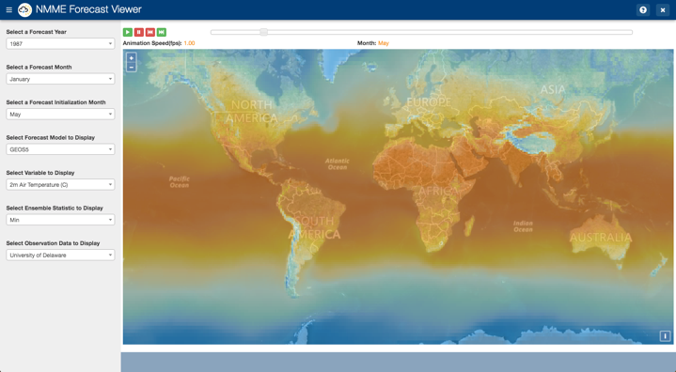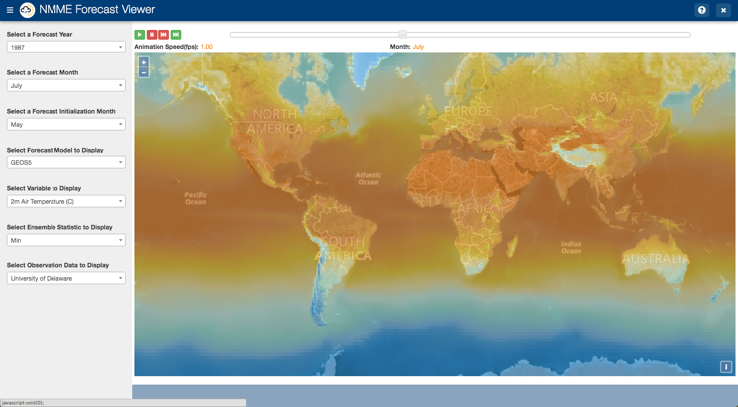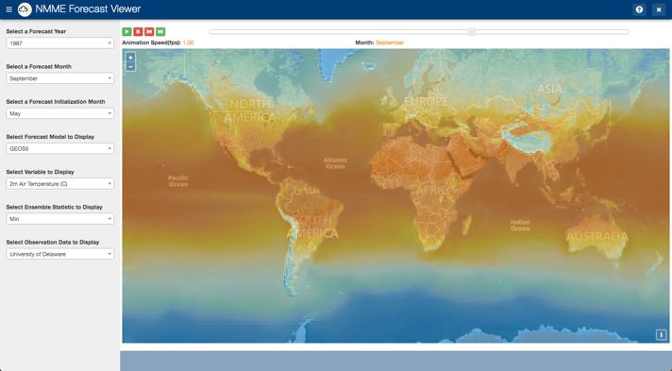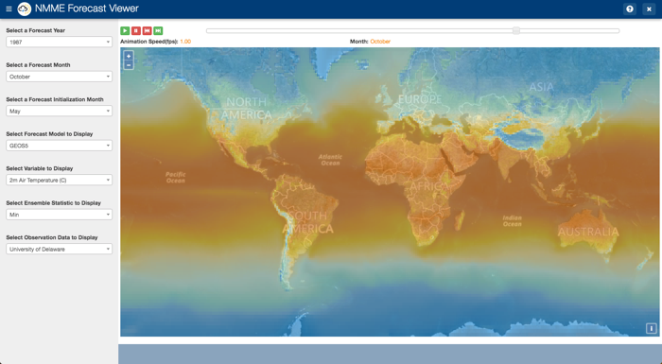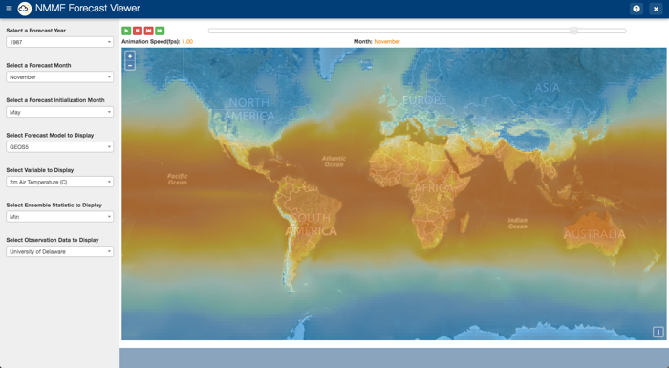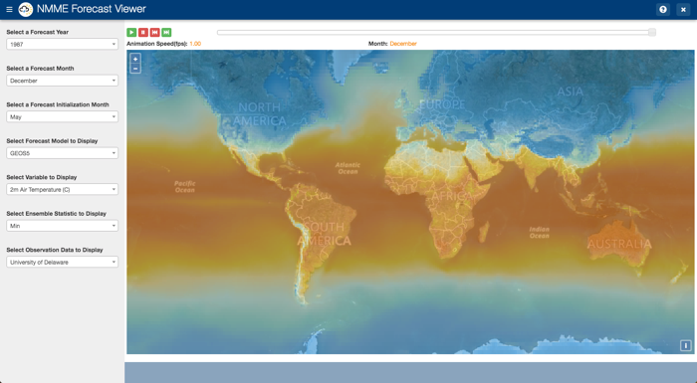

The example above shows the map changing to display the minimum forecasted 2-meter Air Temperature for each month from May until December of 1987 (to save space, it actually shows every other month, though the app cycles through each month.

In addition to being able to visualize the forecasts on the map, the app allows the user to click anywhere on the map and obtain the forecasted value at that location for the time-step being displayed.

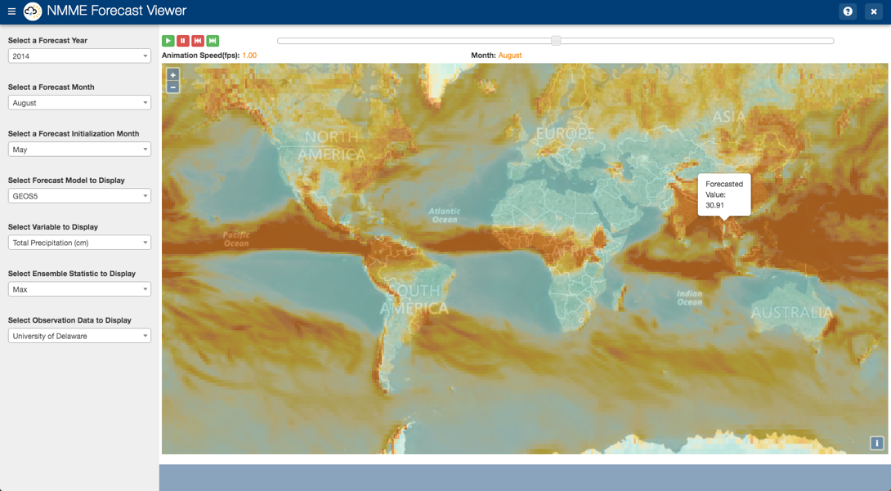

The example above shows that in the month of August 2014, the GEOS-5 model predicted a max monthly rainfall of 30.91 cm.

The code for the current version of the app can be found at <https://github.com/spence97/tethysapp-nmme_viewer.git>.

**Future Development:**

Version 2.0

* A time series plot will be added below the map to display a time series of the forecasted values in comparison with the tercile categories. The plot will look similar to the plot drawn on page 4 of this document, with the mean, min, and max forecasted values (computed from the ensemble members) overlaying the 3 tercile categories (Below Normal, Normal, Above Normal).
* Option to specify a range of years to display in the animation and time series graph instead of only being able to animate 1 year at a time.
  + This will allow the user to contextualize current forecasts by comparing them to past years.
* Ability to change the color scheme of the map based on the selected variable (i.e. high precip values displaying in blue and high temperature values displaying in orange or red).
* Increased data availability
  + More models available (ultimately full NMME datasets should be available)
  + Data from multiple forecast initialization months
  + “Real” forecasts – looking into the future